Power Circuit

Three phase motor connected to full-voltage reversing starter controlled by stop forward and reverse push button station

TASK 4

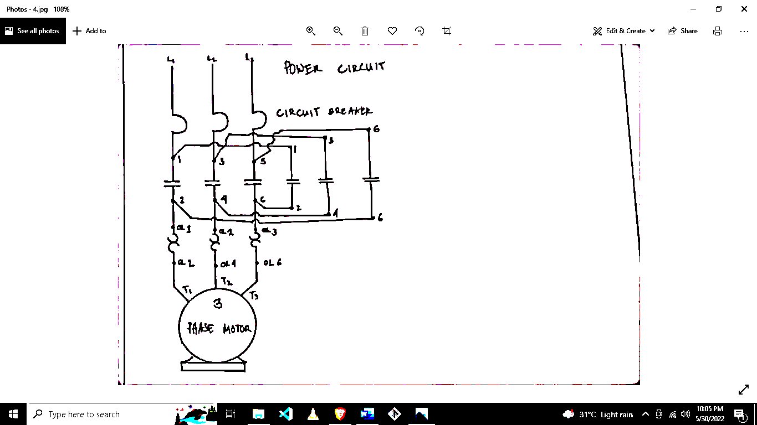

Instructor

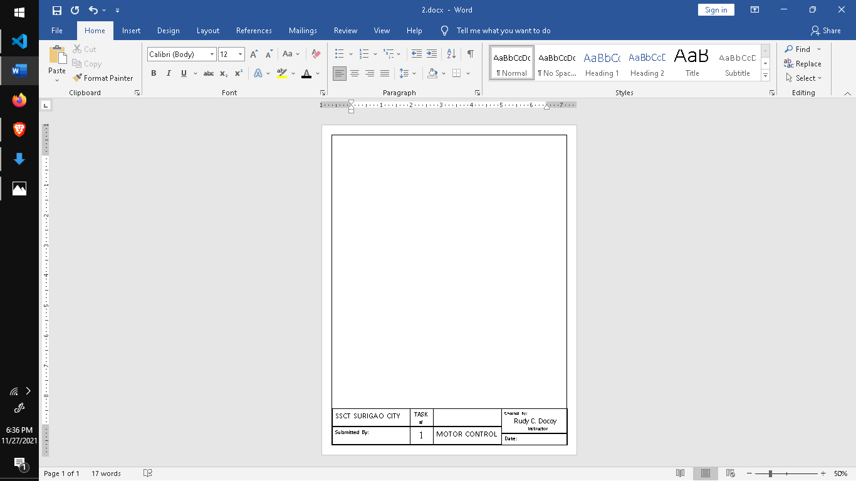

BEET 3C

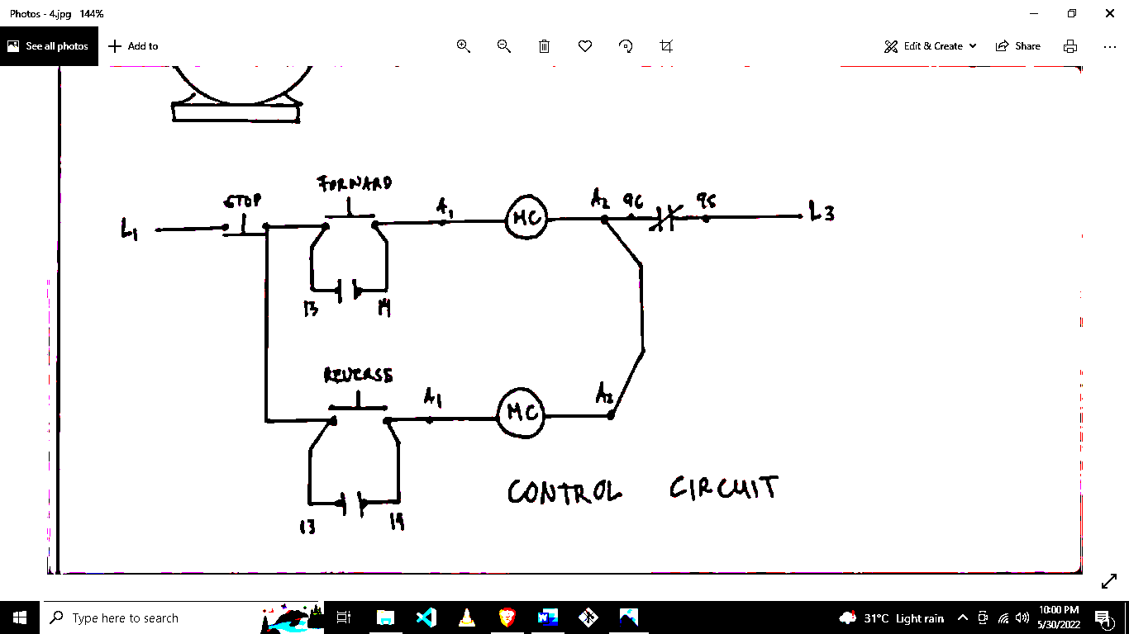

Checked By:

Rudy C. Docoy

MOTOR CONTROL



**Date :**May 31, 2022



TASK #

4

SSCT SURIGAO CITY

Submitted By:

Control Circuit